**SAMPLE LAB REPORT**

**LAB 3**

**SECTION G**

**SUBMITTED BY:**

**HARI BISWA**

**SUBMISSION DATE:**

**9/7/2018**

**Problem**

The purpose of this lab is to understands the concept of functions and create a functions, practicing the writing mod and integer division expressions and formatting output practice. In this activities specifically, I was assigned to create a functions to convert the milliseconds to seconds to minutes precisely. I also was assigned to write a code that’s going to output the numbers like 1,2,3 and 4 if we pressed the shapes buttons on the Blackboard/controller.

**Analysis**

There is a specific constraint that are given to code. On this lab which is lab 3, I was given the formula which a Pythagorean theorem formula which is also named as the mag functions. In this case the mag function which is the Pythagorean theorem is the input which is in the milliseconds and it returned it to “the acceleration’s magnitude was 1.00037356 or 0.8479747, it is also shown in the picture below in the “Capture 2.” After finding the Mag function, I had to turn the specific milliseconds into

**Design**

My goal was to create a file called CPRE185 and Lab 1 inside that file to direct some files (custom 1,2 and front 1, 2 and flat 1,2) into the CPRE185 to the Lab1 using a software called Cygwin. Before following the steps, I had to download those files in the parenthesis above. To do this, there was a specific steps given to follow.

Additionally, those are the basic commands to follow to direct the files. After I have all files downloaded from the canvas, I had followed the algorithms exactly but I end up facing error, and issues and I figured that those issues are capitalization mistakes and going back to fixing it helped me directing the files. Finally I was able to direct the files using Cygwin.

**Testing**

At first, when I tried to change the directory, it seems like it worked but then I checked on top of the Cygwin, my username with files were not there. In the process of finding out what was the cause of not being successful of changing the directory, I figured that it was the capitalization and space errors. I didn’t typed the name of the file correctly and I spaced it. But then afterwards, I the name of the file correctly without spacing and being careful on the capitalizations, I succeeded. I pressed enter on the Cygwin, the line started with my name, CPRE185 and lab1 which is what I wanted.

**Comments**

In doing this lab, I learned not to rush but double check for the errors to not make the same mistakes. The goal was to change the directory for this lab and I did it. Following those algorithm was not that of a difficult. The difficult was to not be able to understand how the Cygwin does work and what it is doing after inputting the algorithm but later I figured it out.

**/* 185 Lab 3 Template */**

**PART 1-3**

/* 185 Lab 3 Template */

#include <stdio.h>

#include <math.h>

/* Put your function prototypes here */

double mag(double ax, double ay, double az);

int minutes(int t);

int seconds(int t);

int millis(int t);

int main(void) {

/* DO NOT MODIFY THESE VARIABLE DECLARATIONS */

int t;

double ax, ay, az;

/* This while loop makes your code repeat. Don't get rid of it. */

while (1) {

scanf("%d,%lf,%lf,%lf", &t, &ax, &ay, &az);

/* CODE SECTION 0 */

//int s = t/1000;

// printf("Echoing output: %8.3d, %7.4lf, %7.4lf, %7.4lf\n", s, ax, ay, az);

/* CODE SECTION 1 */

//printf("At %d ms, the acceleration's magnitude was: %lf\n",

// t, mag(ax, ay, az));

/* CODE SECTION 2 */

printf("At %d minutes, %d seconds, and %d milliseconds it was: %lf\n",

minutes(t), seconds(t), millis(t), mag(ax,ay,az));

double c = mag(ax, ay, az) ;

}

return 0;

}

/* Put your functions here */

double mag(double ax,double ay, double az){

double magnet = sqrt(pow(ax,2)+pow(ay,2)+pow(az,2));

return magnet;

}

int minutes(int t){

int min = t/(1000*60);

return min;

}

int seconds(int t){

int sec = t/1000;

sec = sec % 60;

return sec;

}

int millis(int t){

int millisec = t%1000;

return millisec;

}

**PART 4**

#include <stdio.h>

#include <math.h>

int Count(int a,int b,int c,int d);

int main (void) {

int t,c,x,s;

/* This while loop makes your code repeat. Don't get rid of it. */

while (1) {

scanf("%d,%d,%d,%d", &t ,&c ,&x ,&s);

printf("This is the amount of buttons pressed: %d\n", Count(t,c,x,s));

fflush(stdout);

}

return 0;

}

int Count(int a,int b,int c,int d){

return a+b+c+d;

}

**Capture 1**

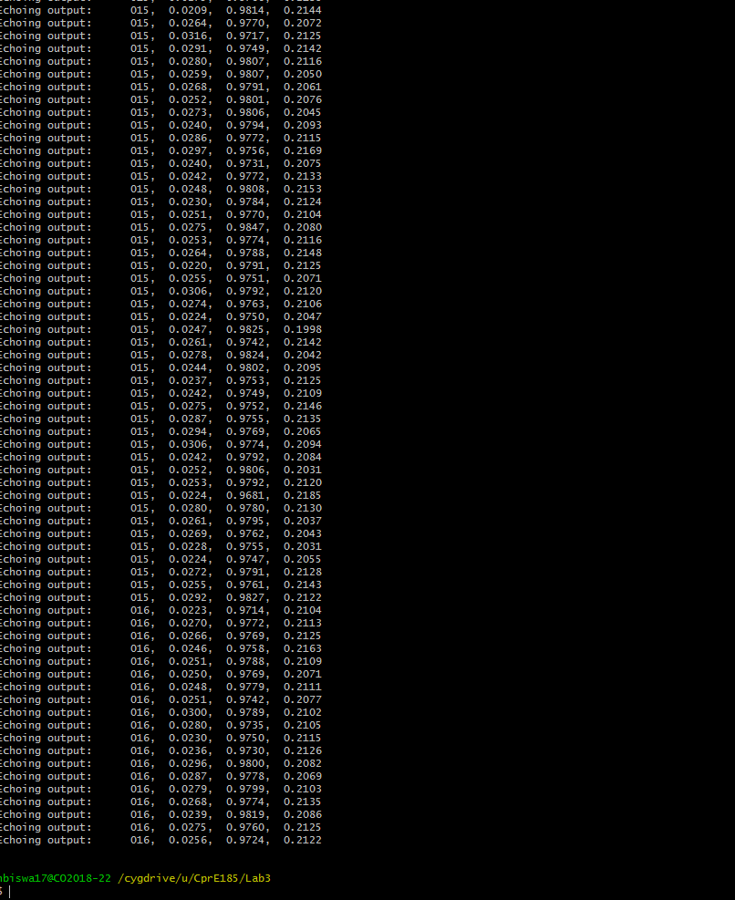

**Capture 2**

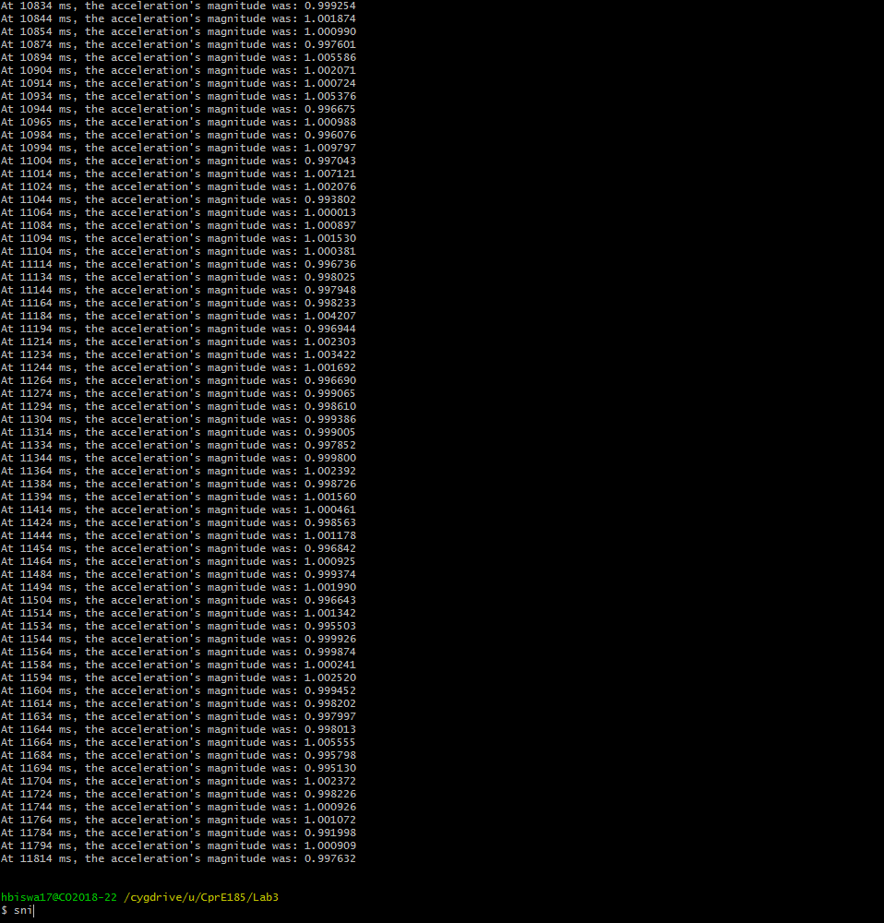

**Capture 3**

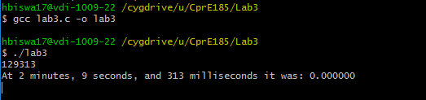

**Capture 4**



**Capture 5**



**Capture 6**



**Capture 7**

